Crop Ecology 2010
HPC-21306

Chapter 10(A):
Lintul-1: potential crop growth
A simple general crop growth model
for optimal growing conditions
(example: spring wheat)
Authors: Marcel van Oijen and Peter Leffelaar (Eds.)
Major text extension (pages A1-A7) by P.A. Leffelaar, August 2008
Teacher: P.A. Leffelaar

Wageningen, 2008



Contents:

LINTUL1 A simple general crop growth model for optimal growing conditions
(example: spring wheat)
Introduction 10A -1
The main model equations and functions of the program 10A -1
Light interception 10A -1
Radiation or Light use efficiency 10A -2
Crop development 10A -3
Allocation of assimilates 10A -4
Leaf area growth 10A -5
Leaf area senescence 10A -6
Start conditions and environmental conditions 10A -7
Explanation of the simulation program 10A -7
1. Initial conditions and run control 10A -8
2. Environmental data and temperature sum 10A -8
3. Leaf growth and senescence 10A -9
4. Light interception and total crop growth rate 10A -10
5. Growth rates and dry matter production of plant organs 10A -11
6. Functions and parameters for spring wheat 10A -11
Reference to literature ‘Introduction to FST’ 10A -13
Exercises with LINTUL1. 10A -14
Table with DAYNUMBER OF YEAR (DOY): 10A -20
Handouts lecture: Lintul1: Potential crop growth 10A -21

LINTUL1 A simple general crop growth model for optimal growing conditions (example: spring wheat)
C.T. de Wit Graduate School for Production Ecology
Dept of Theoretical Production Ecology of the Wageningen Agricultural University, and
DLO-Research Centre for Agrobiology and Soil Fertility
P.O. Box 430, 6700 AK Wageningen

Introduction

LINTUL1 simulates potential growth of a crop, i.e. its dry matter accumulation under ample supply of water and nutrients in a pest-, disease- and weed-free environment, under the prevailing weather conditions. The rate of dry matter accumulation is a function of irradiation and crop characteristics. The model makes use of the common observation that the crop growth rate under favourable conditions is proportional to the amount of light intercepted (Monteith, 1977). Dry matter production is, therefore, modelled as the product of light interception and a constant light use efficiency. The dry matter produced is partitioned among the various plant organs, using partitioning factors defined as a function of the phenological development stage of the crop. The dry weights of the plant organs are obtained by integration of their growth rates over time.
LINTUL1 requires as input physiological properties of the crop (in this case for spring wheat) and the actual weather conditions at the site, characterized by its geographical latitude, i.e. daily maximum and minimum temperatures and irradiation for each day of the year.

The main model equations and functions of the program

LINTUL1 is based on a few mathematical equations and functions that describe the processes leading to dry matter production and grain yield. These equations and functions are described in this section. They can be used in a computer program that automatically computes crop dynamics throughout the season. For those who wish to understand the program implementation, the simulation program is fully explained after the description of the main model equations.

Light interception Radiation, more particularly the photosynthetically active radiation, provides the energy for the process of photosynthesis. The interception of radiation by the crop is thus essential. Assuming a homogeneous canopy, light exponentially decreases with the cumulative leaf area index, counted from the top of the canopy to the soil surface according to Lambert-Beer’s law:
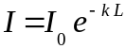 (1)
Where, I₀ is the incident radiation flux of photosynthetically active radiation (PAR, MJ m^{–2}d^{–1}),
I the radiation flux that reaches the soil (PAR, MJ m^{–2}d^{–1}),
k the radiation extinction coefficient (K, m² (ground) m^{–2} (leaf)),
L the leaf area index (LAI, m² (leaf) m^{–2} (ground)).
The radiation extinction coefficient, k, depends on the leaf characteristics and the architecture of the crop: erect leaves intercept less radiation as compared to more horizontal leaves.
The incident radiation flux of photosynthetically active radiation, I₀, is about 50% of the daily total radiation (DTR), so I₀ = 0.5 DTR.
The amount of intercepted photosynthetically active radiation, I_{int}, is the difference between the incident radiation, I₀, and the amount reaching the soil surface, I:
(2)
Both, DTR and L in Eq. (2) vary in time and thus also the amount of intercepted radiation. Daily total radiation is a measured quantity and is contained in the weather data that are needed. For the Light INTerception and UtiLization model we use daily totals that are obtained by integrating a large number of measurements taken during the day. The (green) leaf area index, L, will increase with time due to growth of new leaves, but at a certain moment, leaf senescence will be stronger and the leaf area will decrease again. Leaf area dynamics will be discussed in a later section.
Combining the actual amount of intercepted photosynthetically active radiation with the radiation use efficiency enables us to calculate the daily growth rate of a crop.

Radiation or Light use efficiency Monteith (1977) showed that a graph of crop growth rate versus the cumulative amount of absorbed photosynthetically active radiation gives a straight line, Figure 1.

Crop growth rate  g / (m² week) | 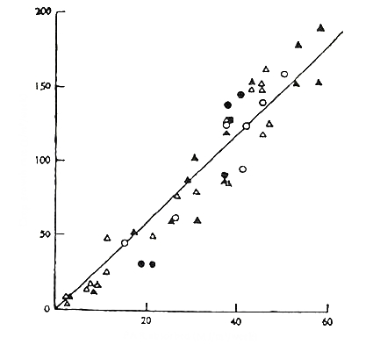  PAR absorbed, MJ / (m² week) | Legend  Circles : Barley  Triangles : wheat
Figure 1. Crop growth rate versus the cumulative amount of absorbed photosynthetically active radiation (Gallagher and Biscoe, 1978).

The slope of this line gives an estimate of the radiation use efficiency (RUE) expressed in g dry matter per MJ of absorbed radiation. The meaning of the numerator (g dry matter) and the denominator (MJ of absorbed radiation) of this ratio is extensively discussed in the review article by Sinclair and Muchow (1999).
Crop growth rate (dW/dt; GTOTAL) can now be calculated as:
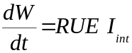 (3)
with the unit g (dry matter) / (m² (ground) d). The crop weight is obtained by integrating Eq. (3) over time, usually a growing season:
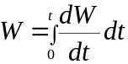 (4)
We need to distinguish between growth and development. Growth is determined by the product of radiation interception and the efficiency by which this radiation is used to form crop assimilates (Eq. 3). Development is determined by physiological age as discussed in the following section.

Crop development Crops pass through a number of developmental stages (DVS) during their live cycle. These different stages control the partitioning of assimilates or dry matter. In general, temperature has the strongest effect on development. A problem in quantifying this effect is that it is not possible to measure development rate directly. Instead, it must be derived from the period of time elapsed between two distinct development stages. The rate of development, dDist/dt, can than be derived using the equation:
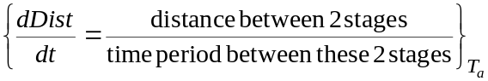 (5)
where “distance between 2 stages” may, for example, be the distance between emergence and anthesis. Such a distance could be termed 1, or 100% or so, and does not have a unit. It appears from Eq. (5) that the “time period between these 2 stages”, the denominator, in days, must be assessed for a series of constant air temperatures, T_{a}. Development rate is found to be roughly linearly related to temperature over a wide range, although there is usually a maximum in the response curve above which the development rate will decrease again. A graph of dDist/dt versus the temperature, T, is shown in Figure 2.
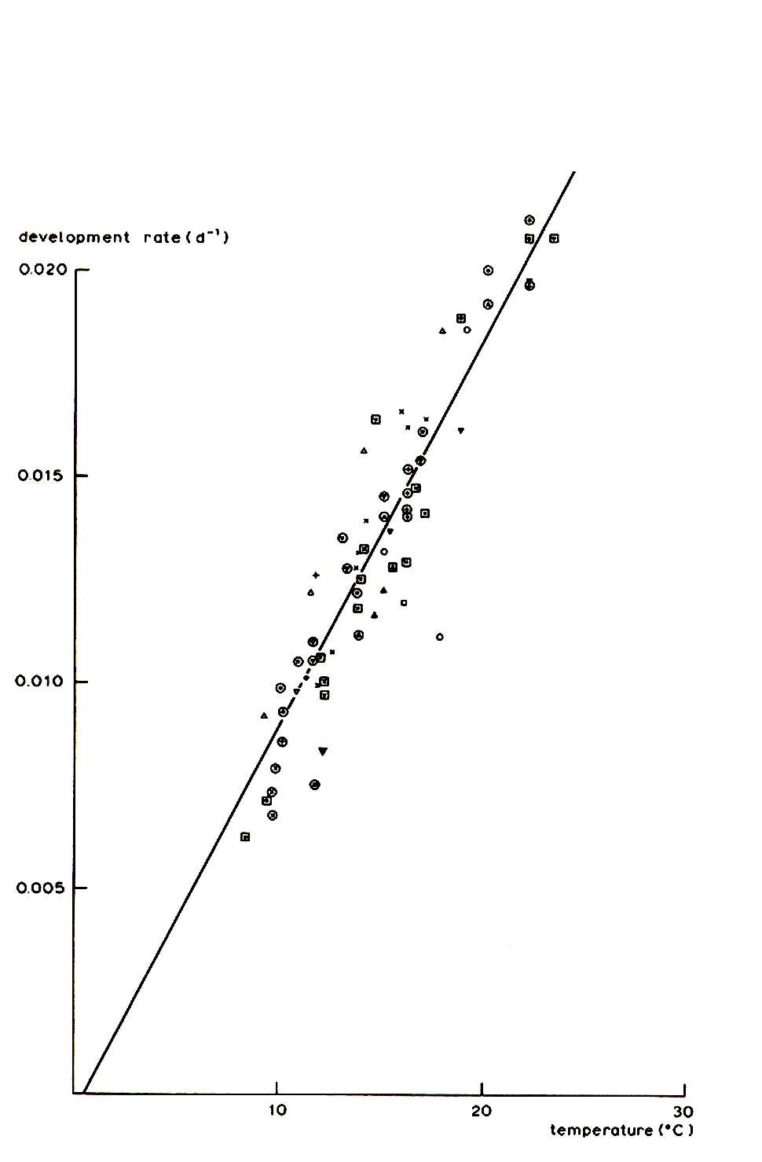

dDist/dt (d^{–1})

Figure 2. Development rate of spring wheat as a function of temperature from emergence till flowering (van Keulen and Seligman, 1987).

The extrapolation of the line to low temperatures yields an intercept with the temperature axis. This is often called the base temperature, T_{b} (TBASE), below which there is no or a hardly measurable development rate. Provided that air temperature, T_{a} (DAVTMP), lies between the base temperature, T_{b}, and the optimum temperature, beyond which the development starts to level off, the development rate is proportional to the integrated temperature
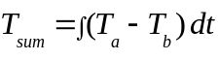 (6)
From the slope of the line in Figure 2, the temperature sum, T_{sum}, to go from one development stage to the next can be calculated. The slope, α, will have the unit 1/(d ˚C), and thus 1/α is the temperature sum.
The development rate, dDist/dt, is derived from experiments at constant air temperatures, T_{a}. In the field, however, temperatures are not constant. The temperature sum as a measure for physiological age or development stage nevertheless often works fine because of the instantaneous reaction of the crop to a change in temperature.

Allocation of assimilates In principle, photosynthesis yields assimilates that need to be partitioned over the different plant organs. In the radiation use efficiency approach, however, radiation is directly used to calculate the production of dry matter via the value of the RUE. Thus, dry matter is partitioned over the plant organs: roots, stem, leaves and storage organs. The different developmental stages control the partitioning of assimilates or dry matter. Assessing the relationships between phenological development stages and the fractions of the dry matter that are partitioned towards the different organs is still only possible by empirical work. The relationships have been assessed for a number of important crops. Figure 3 shows the data points for spring wheat.
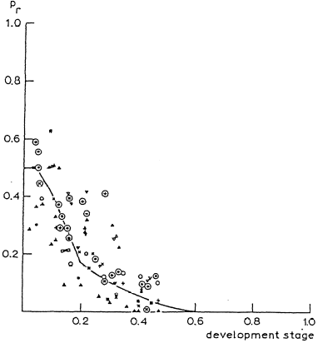 | 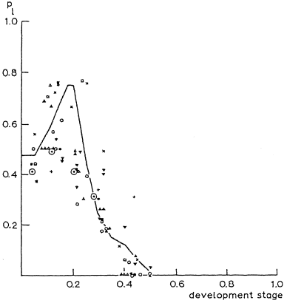 | 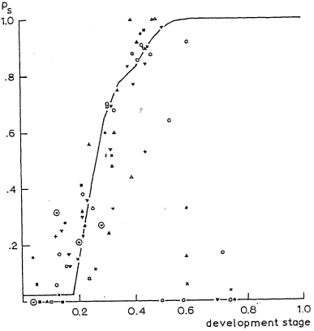
F_{rt}: allocation to roots | F_{lv}: allocation to leaves | F_{st}: allocation to stem and  storage organs
Figure 3. Allocation patterns for spring wheat (van Keulen and Seligman, 1987). Development stage one in the figures is equivalent to 2080 ˚Cd. Anthesis occurs at a development stage of 0.5.

It can be seen from the figure that in the beginning much dry matter is invested in the roots and the leaves, and that after flowering, when the development stage equals 0.5, root and leaf growth stop. It appears that after DVS=0.5 all the dry matter is invested in the stem, but in fact the allocation to the stem is also ceasing after DVS=0.5 and all the dry matter production is invested in the storage organs. Such empirical data can only be used through functions representing the partitioning fractions as a function of development stage, where the sum of the fractions should always be equal to 1.0.
The growth of each plant organ can now be calculated from Eq. (3) and the partitioning fractions depicted in Figure 3:
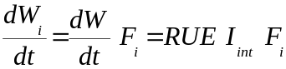 (7)
where i represents the root (rt), stem (st), leaves (lv) or storage organ (so) of the plant, respectively. Since leaves partially senesce during the growing season, the equation for the net rate of change of green leaves, dW_{lvg}/dt (RWLVG), is slightly different:
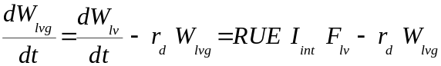 (8)
where the leaf death rate is taken proportional to the green leaf weight, W_{lvg} (WLVG, g DM m^{–2}) and a relative senescence rate, r_{d} (RDR, d^{–1}). The relative death rate is further detailed in the section about Leaf area senescence. The senescence rate r_{d} W_{lvg} in Eq. (8) is similar to DLV in the LINTUL1 program. The other organs (root, stem, storage organs) are assumed to negligibly die during the season.
Describing crop growth and dry matter allocation according to Eq. (7) implies that it is assumed that all dry matter produced in a day is directly distributed over the plant organs, and thus no reserve pool of assimilates or dry matter is considered. Redistribution of dry matter at the end of the season to the storage organs is assumed negligible.

Leaf area growth Leaves are the major photosynthesizing organs, and the calculation of intercepted photosynthetically active radiation, PAR, is largely based on their surface area. Correct simulation of the time course of the leaf area index, L (LAI), is the first requirement for correct crop growth calculations. Roughly, two different situations exist with respect to the formation of new leaf area: its growth may be sink-limited or it may be source-limited.
During juvenile growth, temperature is the overriding factor, as the rate of leaf appearance and final leaf size are constrained by temperature through its effect on cell division and extension, rather than by the supply of assimilates. In these early, sink-limited stages, leaf area increases approximately exponentially over time, Eq. (9):
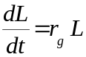 (9)
with r_{g} the relative growth rate. This relative growth rate is the product of r_{l} (RGRL), the relative growth rate of leaf area during the juvenile exponential growth phase in (˚Cd)^{–1}, and the effective temperature T_{eff} (DTEFF), which equals (T_{a}–T_{b}) if T_{a} ≥ T_{b}:
r_{g} = r_{l} T_{eff} (10)
Integrating Eq. (9) and substituting Eq. (10) yields Eq. (11):
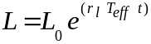 (11)
Eq. (11) can be used to derive the exact rate of leaf area development over e.g. daily time intervals. To this purpose Eq. (11) is rewritten as
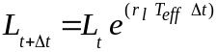
with L_{t} and L_{t+Δt} the current leaf area and the leaf area at the end of a time step Δt (DELT, d), respectively. Subsequently, the slope of the exponential curve can be approximated by:
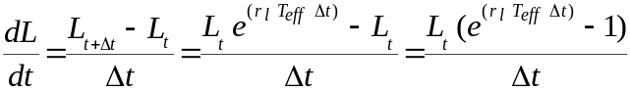 (12)
Equation 12 is used in the LINTUL1 program, rather than Eq. (9), because Eq. (12) does not suffer from the accumulation of numerical integration errors.
Examination of unpublished field data suggests that a safe approximation is to restrict the exponential phase to the situation where L < 0.75 m² m^{–2} and T_{SUM} < 330 °Cd.
In later development stages, leaf area expansion is increasingly restricted by assimilate supply (source-limited). Branching and tillering generate an increasing number of sites per plant where leaf initiation can take place and an increasing number of cells that can expand, while mutual shading of plants and leaves reduces the assimilate supply per growing point and per cell. During this stage (L > 0.75 m² m^{–2} or T_{SUM} > 330 °Cd), the model calculates the growth of leaf area by multiplying the simulated rate of increase in leaf weight, dW/dt F_{lv} (GLV, g (leaf) m^{–2} (soil) d^{–1}) by the specific leaf area of new leaves, S_{la} (SLA, m² (leaf) g^{–1} (leaf)), Eq. (13):
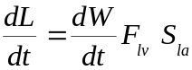 (13)
where dW/dt is defined by Eq. (3). The dynamics of S_{la} are not well understood yet. Therefore, it is assumed constant throughout the season.

Leaf area senescence The senescence rate of L (DLAI, d^{–1}), is described on the basis of a relative death rate, r_{d} (RDR, m² (leaf) m^{–2} (soil) / (m² (leaf) m^{–2} (soil) d) or just d^{–1}), Eq. (14)
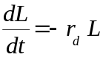 (14)
where r_{d} is set to the maximum of either a relative death rate due to ageing, r_{d-ag} (RDRDV, d^{–1}), or one due to self-shading, r_{d-sh} (RDRSH, d^{–1}):

r_{d} = max (r_{d-ag}, r_{d-sh}) (15)

with r_{d-ag} = f(T) and r_{d-sh} = f(L).
The r_{d-ag} = f(T) is specified by the following (x,y) pairs: (-10 , 0.03) , (10 , 0.03) , (15 , 0.04) , (30 , 0.09) , (50 , 0.09), where -10, 10, 15, 30 and 50 are temperatures and the values 0.03, 0.04 and 0.09 are the corresponding relative death rates due to ageing. Death of leaves due to ageing only occurs after anthesis, as indicated by T_{sum} ≥ T_{sum-anthesis} (TSUMAN).
The r_{d-sh} = f(L) equals zero for L smaller than a critical leaf area index, L_{cr}, which is set to 4 for spring wheat (LAICR, m² (leaf) m^{–2} (soil)). For leaf area index values exceeding L_{cr}, r_{d-sh} increases linearly with increasing L till a maximum value, r_{d-shmx} = 0.03 (RDRSHM, d^{–1}) at L = 8.

Start conditions and environmental conditions Crop growth starts with emergence, which can be triggered either by an accumulation of heat units or just by reaching a preset date. In the first case one needs to have information about the sowing date and the temperature sum from sowing to emergence. In our case we did not have such information and therefore, a preset date is taken.
For an accurate description of the establishment of small plants, much information is needed. In the case of the light interception and utilization model we have chosen to initialize leaf area as if it appears at once: leaf area at emergence amounts to 0.012 m² (leaf) m^{–2} (soil).
Quite some other parameters are needed too; see the statements starting with the words PARAM and FUNCTION in the program listing. These values were gathered from experimental data. Furthermore, weather data are needed. The Plant Production Systems group has a large collection of daily weather data from the Netherlands, but also from a large number of other countries. For the potential growth model, we only need daily global radiation and minimum and maximum temperatures.
The model should stop making calculations at the end of the season, or when the temperature sum for maturity has been reached, (TSUM = 2080 for spring wheat).

Explanation of the simulation program

Remark: The abbreviations and units used in the following explanation of LINTUL1 are given at the end of Chapter 10B. Some of the specifics of the FST language, such as INTGRL, AFGEN, INSW, etc. are also summarized there. Full details can be found in the document “Ch10_FST-Introduction” on the course-website (see link mentioned in section Reference to literature “Introduction to FST” of this chapter).

LINTUL1 is written in FST, the FORTRAN Simulation Translator (van Kraalingen et al., 1994), which runs on various computer platforms, e.g. IBM-PC or compatible, and Apple-Macintosh.
The explanatory text follows as closely as possible the computer listing of the model. Each section starts with a number of lines copied from this listing. In the following text, the inevitably awkward abbreviative terminology so typical for computer modelling, is then explained. Units of all variables and data are specified.

DEFINE_CALL GLA(INPUT,INPUT,INPUT,INPUT,INPUT,INPUT,INPUT,INPUT, ...
INPUT,INPUT, OUTPUT)

TITLE LINTUL1

FST requires, before the program starts, a definition of the calls for subroutines that are used in the program. All variables in the subroutine-call have to be defined as INPUT or OUTPUT variables. These definitions will be used by FST for sorting the program lines. After the definition of the subroutine-call the program starts with the TITLE of the program.

1. Initial conditions and run control

* Initial conditions
INCON ZERO = 0.
WLVI = LAII / SLA

FST requires the name of a constant as initial value for an integration. In case this integration starts at zero (e.g. summation of temperature) the initial constant ZERO is used.
The initial weight of leaves at emergence (WLVI, g (leaf) m−2 (ground)) is calculated as the ratio of initial Leaf Area Index (LAII, m2 (leaf) m−2 (ground)) and the Specific Leaf Area (SLA, m2 (leaf) g−1 (leaf)).

* Run control
FINISH TSUM > 2080.

The simulation stops if the crop is mature. This occurs if the temperature sum reaches the value 2080 °Cd.

TIMER STTIME = 1.; FINTIM = 200.; DELT = 1.; PRDEL = 5.
TRANSLATION_GENERAL DRIVER='EUDRIV'
PRINT LAI, WSOTHA, WSO, WST, WLV, WRT, TSUM, DAVTMP, DTR

Simulation may start earlier than emergence. This is specified in the TIMER statement (STTIME = 1 means: 1 January). Simulation is executed with time steps of one day (DELT=1.), with rectilinear integration (Euler) of the rates (DRIVER='EUDRIV'). Output is produced every fifth day (PRDEL=5.). To make sure that the simulation does not continue endlessly, the finish time (FINTIM) is set at day 200. The simulation will thus stop either at 200 days or when the temperature sum has reached 2080 °Cd.
In the PRINT line any variable can be specified. Values are written to the output file at every print interval (PRDEL).

2. Environmental data and temperature sum

DYNAMIC
WEATHER WTRDIR='C:\SYS\WEATHER\'; CNTR='IT'; ISTN=3; IYEAR=1985
* Reading weather data from weather file:
* RDD Daily global radiation J/(m2*d)
* TMMN Daily minimum temperature degree C
* TMMX Daily maximum temperature degree C

DTR = RDD/1.E+6
DAVTMP = 0.5 * (TMMN + TMMX)
DTEFF = MAX ( 0., DAVTMP-TBASE )
EMERG = INSW(TIME-DOYEM, 0., 1.)
TSUM = INTGRL(ZERO, RTSUM)
RTSUM = DTEFF*EMERG
Actual daily total global radiation (RDD, J m−2 d−1) is read from the weather data file, which contains measured values for solar radiation (400 - 2000 nm) for all days of the year. RDD is converted into other units by division by 106, to give DTR in MJ m−2 d−1.
Daily maximum and minimum temperatures (TMMX and TMMN, respectively, °C) are also read from the weather data file, containing measured values for all days of the year. DAVTMP is the daily average temperature. Since many growth processes are temperature dependent above a certain threshold temperature, an effective temperature (DTEFF) is calculated. For spring wheat, the threshold value (TBASE) is 0 °C. The variable EMERG equals 0 before emergence, and 1 after emergence, when TIME is equal or larger than the daynumber of emergence (DOYEM). For explanation of the MAX and INSW functions, see the description of FST (van Kraalingen et al., 1994). Note that TIME may become larger than 365, in case the simulation runs from one calendar year into the next year.
Phenological development of crops is more closely related to thermal time, i.e. the accumulated number of degree-days after emergence, than to the age of the crop in days. Therefore, the model calculates the temperature sum (TSUM, °Cd) by accumulating the daily values of effective temperature after emergence (RTSUM, °C).

3. Leaf growth and senescence

CALL GLA(TIME,DOYEM,DTEFF,TSUM,LAII,RGRL,DELT,SLA,LAI,GLV,...
GLAI)
GLV = FLV * GTOTAL

DLAI = LAI * RDR
RDR = MAX(RDRDV, RDRSH)
RDRDV = INSW(TSUM-TSUMAN, 0., AFGEN(RDRT, DAVTMP))
RDRSH = LIMIT(0., RDRSHM, RDRSHM * (LAI-LAICR) / LAICR)
DLV = WLVG * RDR

RLAI = GLAI - DLAI
LAI = INTGRL(ZERO, RLAI)

The area of green leaves is the major determinant for light interception and utilization. The leaf area index (LAI, m2 (leaf) m−2 (ground)) is obtained by integrating the net result of the leaf growth rate (GLAI, m2 m−2 d−1), and the leaf senescence rate (DLAI, m2 m−2 d−1).
GLAI is calculated, depending on the phenological development stage, in the Subroutine GLA. Before seedling emergence (TIME < DOYEM), GLAI equals zero. At emergence, GLAI = LAII/DELT. After emergence, light intensity and temperature are the environmental factors influencing the rate of leaf area expansion.
During juvenile growth, temperature is the overriding factor, as the rate of leaf appearance and final leaf size are constrained by temperature through its effect on cell division and extension, rather than by the supply of assimilates. In these early stages, leaf area increases approximately exponentially over time. Examination of unpublished field data suggests that a safe approximation is to restrict the exponential phase to the situation where LAI < 0.75 m2 m-2 and TSUM < 330 °Cd. This is programmed in the Subroutine GLA. Exponential leaf area development is described analytically by:
LAI(t+DELT) = LAI(t) * EXP(RGRL * DTEFF * DELT)
so that the rate of increase in leaf area during juvenile growth is:
GLAI = (LAI(t + DELT) - LAI(t)) / DELT
= LAI(t) * (EXP(RGRL * DTEFF * DELT) - 1.) / DELT
in which LAI(t) is the current leaf area (m2 m-2), RGRL is the relative growth rate of leaf area, expressed per degree-day ((°Cd)−1), DELT is the time step of integration (d) and DTEFF is the daily effective temperature (°C).
In later development stages, leaf area expansion is increasingly restricted by assimilate supply. Branching and tillering generate an increasing number of sites per plant where leaf initiation can take place and mutual shading of plants further reduces the assimilate supply per growing point. During this stage (LAI > 0.75 m2 m-2 or TSUM > 330 °Cd), the model calculates the growth of leaf area by multiplying the simulated increase in leaf weight (GLV, g m−2 d−1) by the specific leaf area of new leaves (SLA, m2 g−1).
The senescence rate of LAI (DLAI, d−1) is described on the basis of a relative death rate (RDR, (m2 m−2)/(m2 m−2) d−1), set at the maximum of either a relative death rate due to ageing (RDRDV) or one due to self-shading, RDRSH. The latter equals zero for LAI smaller than 4 (= LAICR), and above that value increases linearly with increasing LAI till a maximum value of 0.03 (= RDRSHM) at LAI = 8. For the meaning of the LIMIT function, see the description of FST, van Kraalingen et al., 1994.
RDRDV equals zero as long as TSUM < TSUMAN (pre-anthesis stage) and is a function of the average daily temperature (DAVTMP, °C) for TSUM > TSUMAN.
The death rate of leaves in terms of weight (DLV, g m−2 d−1) is defined using the same relative senescence rate (RDR) that also applies to LAI, but now multiplied with the weight of the green leaves (WLVG, g m−2).

4. Light interception and total crop growth rate

PARINT = 0.5 * DTR * (1. - EXP(-K*LAI))
GTOTAL = LUE * PARINT

Photosynthetically active radiation (PAR), wavelengths between 400 and 700 nm, is about 50% of the incoming global radiation (0.5*DTR). The daily values of intercepted photosynthetically active radiation (PARINT, MJ m−2 d−1) are derived by assuming that light interception increases with LAI according to a negative exponential function of leaf area index, characterized by a crop-specific light extinction coefficient (K, m2 (ground) m−2 (leaf)).
The overall daily growth rate of the crop (GTOTAL, g m−2 d−1) is then calculated by multiplying the amount of light intercepted by a constant light use efficiency (LUE, g MJ−1).

5. Growth rates and dry matter production of plant organs

FRT = AFGEN( FRTTB, TSUM )
FLV = AFGEN( FLVTB, TSUM )
FST = AFGEN( FSTTB, TSUM )
FSO = AFGEN( FSOTB, TSUM )

WLVG = INTGRL( WLVI, RWLVG)
WLVD = INTGRL( ZERO, DLV )
WST = INTGRL( ZERO, RWST )
WSO = INTGRL( ZERO, RWSO )
WSOTHA = WSO / 100.
WRT = INTGRL( ZERO, RWRT )
WLV = WLVG + WLVD
RWLVG = GTOTAL * FLV - DLV
RWST = GTOTAL * FST
RWSO = GTOTAL * FSO
RWRT = GTOTAL * FRT

Partitioning of biomass over the various plant organs is described by fixed distribution factors, defined as functions of the temperature sum. Before anthesis (TSUM < TSUMAN) the highest distribution factors are those for roots (FRT), leaves (FLV) and stems (FST), thereafter most of the biomass is allocated to the storage organs, i.e. grains (FSO). This allocation-pattern is embodied in the FUNCTION-statements given in the next section.
Dry weights of the various plant organs (roots (WRT, g m−2), green leaves (WLVG, g m-2), dead leaves (WLVD, g m−2), stems (WST, g m−2), storage organs (WSO, g m−2)) are obtained through integration of the respective growth rates. For convenience, the program calculates yield in tons per ha as well (WSOTHA, t ha−1).

6. Functions and parameters for spring wheat

* Section 1
PARAM LAII = 0.012; SLA = 0.022
* Section 2
PARAM TBASE = 0.
* Section 3
PARAM DOYEM = 32.
PARAM RGRL = 0.009; LAICR = 4.; TSUMAN = 1110. ; RDRSHM = 0.03
FUNCTION RDRT = -10.,0.03, 10.,0.03, 15.,0.04, 30.,0.09, 50.,0.09
* Section 4
PARAM LUE = 3.0; K = 0.6
* Section 5
* Partitioning tables for leaves (LV), stems (ST),
* storage organs (SO) and roots (RT):
FUNCTION FRTTB = 0.,0.50, 110.,0.50, 275.,0.34, 555.,0.12, ...
780.,0.07, 1055.,0.03, 1160.,0.02, 1305.,0. , 2500.,0.
FUNCTION FLVTB = 0.,0.33, 110.,0.33, 275.,0.46, 555.,0.44, ...
780.,0.14, 1055.,0. , 2500.,0.
FUNCTION FSTTB = 0.,0.17, 110.,0.17, 275.,0.20, 555.,0.44, ...
780.,0.79, 1055.,0.97, 1160.,0. , 2500.,0.
FUNCTION FSOTB = 0.,0. , ...
1055.,0. , 1160.,0.98, 1305.,1. , 2500.,1.
END
* Start of rerun section

PARAM DOYEM = 60.
END

STOP

* Start of Subroutine section (see Section 3)

* ------------------------------------------------------------------*
*SUBROUTINE GLA *
*Purpose:This subroutine computes daily increase of leaf area index *
* (m2 leaf/ m2 ground/ d) *
* ------------------------------------------------------------------*
SUBROUTINE GLA(TIME,DOYEM,DTEFF,TSUM,LAII,RGRL,DELT,SLA,LAI,GLV,
$ GLAI)
IMPLICIT REAL (A-Z)

*---- Growth during maturation stage:
GLAI = SLA * GLV

*---- Growth during juvenile stage:
IF ((TSUM.LT.330.).AND.(LAI.LT.0.75))
$ GLAI = LAI * (EXP(RGRL * DTEFF * DELT) - 1.) / DELT

*---- Growth at day of seedling emergence:
IF ((TIME.GE.DOYEM).AND.(LAI.EQ.0.))
$ GLAI = LAII / DELT

*---- Growth before seedling emergence:
IF (TIME.LT.DOYEM) GLAI = 0.

RETURN
END

Reference to literature ‘Introduction to FST’

For those who want to know more about FST-program an introductory reader will be published on the EDU-web vakkensite (https://portal.wur.nl/Courses/HPC21306_2008_3/default.aspx):

FST,
the Fortran Simulation Translator
Authors: D.W.G. van Kraalingen, C. Rappoldt and H.H. van Laar
Teacher: Peter Leffelaar

Text from the book:
On systems analysis and simulation of ecological processes; with examples in CSMP, FST
and FORTRAN. Second Edition. P.A. Leffelaar, 1999 (Ed.).
Series title: Current Issues in Production Ecology, Vol 4. Kluwer academic publishers, 318 pp.

Exercises with LINTUL1.

New questions dec 2007 to be inserted from file PAL21 January2008 QuestionsLintul-1.pdf directly (6 pages)

Table with DAYNUMBER OF YEAR (DOY):
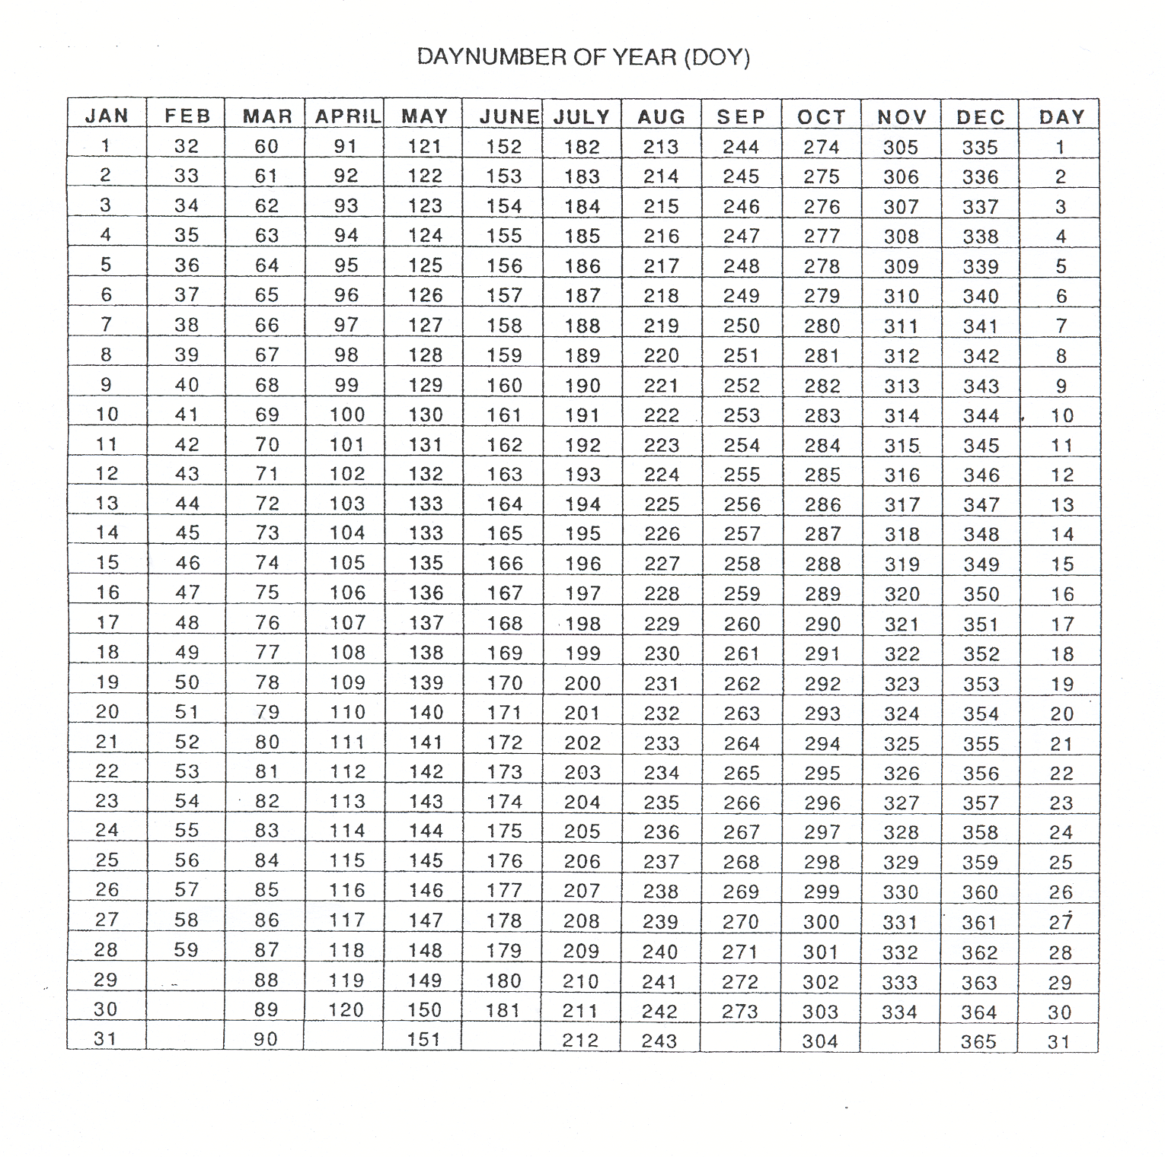

Handouts lecture: Lintul1: Potential crop growth

Abbreviations inside brackets refer to the names in the LINTUL1-program. So, e.g. I₀ is similar to PAR.

